**ORGANIC FOOD**

**A PROJECT REPORT**

***Submitted by***

**Likitha Siripurapu**

***in partial fulfillment for the award of the degree***

***of***

**BACHELOR OF COMPUTER APPLICATION**



**Lovely Professional University, Punjab**

**November 2024**

**Lovely Professional University, Punjab**

**BONAFIDE CERTIFICATE**

Certified that this project report **“………. ORGANIC FOOD**

**……………..”**

is the Bonafide work of “**…………. Likitha Siripurapu.…………...”**

who carried out the project work under my supervision.

**SIGNATURE**

**SUPERVISOR**

**SIGNATURE**

**CLASS MENTOR**

**SIGNATURE**

**HEAD OF THE DEPARTMENT**

**TABLE OF CONTENTS**

|  |  |  |
| --- | --- | --- |
| **SR. NO.** | **TOPIC** | **PAGE NO** |
| 1 | Title Page | 1 |
| 2 | Bonafide Certificate | 2 |
| 3 | Table of Contents | 3 |
| 4 | Introduction of the Project | 4 |
| 5 | Technologies used | 4 |
| 6 | Workflow | 5 |
| 7 | Code Snippets of the Project | 6-20 |
| 9 | Screenshots of the Project | 21-25 |
| 10 | Conclusion | 26 |

**INTRODUCTION: -**

That is an organic food online website focused on homemade products, which must offer customers a convenient, reliable source of fresh, natural, and chemical-free foods directly kitchen. The variety of products that may be suggested could inc-lude fruits, vegetables, dairy, baked goods, and artisanal items, all made with organic ingredients and sustainable practices. Organic farming does not use synthetic chemical pesticides or fertilizers or genetically modified organisms, making the food organic and hence healthier as well as friendlier to the environment than conventional farming

**TECHNOLOGY USED: -**

**HTML (Hypertext Markup Language):-**

HTML is the standard markup language used to create web pages. It is a combination of Hypertext and Markup language. Hypertext defines the link between web pages, and Markup defines the text document within tags to structure the web pages.

**CSS (Cascading Style Sheets):-**

CSS is used to define styles for your web pages, including the design, layout and variations in display for different devices and screen sizes.

**GitHub Link: -**

**WORKFLOW**

Start



Project Planning



Providing HTML structure



Improving design by CSS



Adding other features



Adding various subtopics



Completing frontend of the website



End

Code Snippets

Home page code: -

<!DOCTYPE html>

<html lang="en">

<head>

    <meta charset="UTF-8">

    <meta name="viewport" content="width=device-width, initial-scale=1.0">

    <title>RESTAURANT</title>

    <link rel="stylesheet" href="restaurant.css">

</head>

<body>

    <header>

        <h1>ORGANIC FOOD ONLINE MENU CARD</h1>

        <nav>

            <ul>

                <li><a href="ORGANIC VEGETABLES.HTML">vegetables</a></li>

                <li><a href="ORGANIC FRUITS.HTML">Fruits</a></li>

                <li><a href="ORGANIC DRINKS.HTML">Drinks</a></li>

                <li><a href="ORGANIC SNACKS.HTML">snacks</a></li>

                <li><a href="ORGANIC SNACKS.HTML">Contact us</a></li>

                <li><a href="contact us food.html">Order us</a></li>

            </ul>

        </nav>

    </header>

<br><br><br>

 <div class="njoy"><P><B>ORDER NOW AND ENJOY YOUR FOOD</B></P></div>

    <section class="web">

        <img src=""> <br><br>

        <section class="second">

            <div class="one">

             <div class="div1">

                <h1 style="color: rgb(247, 241, 241); "> ORGANIC VEGETABLES</h1>

                <a href="ORGANIC VEGETABLES.HTML"><img src="https://freedesignfile.com/upload/2018/04/Summer-fresh-organic-vegetables-fruits-Stock-Photo-13.jpg" height="220px" width="auto"></a></div>

                <div class="villan1">

                    <h1 style="color:white;"> ORGANIC FRUITS</h1>

                    <a href="ORGANIC FRUITS.HTML"><img src="https://www.diagnosisdiet.com/assets/images/7/fruit-og-0dd51728.jpg" height="220px" width="auto"></a>

                </div>

                <div class="villan1">

                    <h1 style="color: white;">ORGANIC DRINKS</h1>

                    <a href="ORGANIC DRINKS.HTML"><img src="https://static.toiimg.com/thumb/msid-47200525,width=1200,height=900/47200525.jpg" height="320px" width="auto"></a>

                </div>

                <div class="villan1">

                    <h1 style="color: white;">ORGANIC SNACKS</h1>

                    <a href="ORGANIC SNACKS.HTML"><img src="https://media.licdn.com/dms/image/D5612AQHWzvLBTWy9yg/article-cover_image-shrink_720_1280/0/1701934439129?e=2147483647&v=beta&t=GwhcnPXA3FCXI5HODo3V_KKnFU4vhPXR8V10E--KShI" height="320px" width="auto"></a>

                </div>

                </div>

            </section>

        <footer>

            <p>Contact Us: organicfood@gmail.com</p>

        </footer>

    </body>

    </html>

CSS:

body {

    font-family: Arial, sans-serif;

    margin: 0;

    padding: 0;

    line-height: 1.6;

    background-repeat: no-repeat;

    background-size: cover;

    color: #fff;

    background-image:url("https://png.pngtree.com/thumb_back/fh260/background/20240717/pngtree-empty-wood-table-with-blur-green-nature-background-wooden-top-for-image_16016098.jpg")

}

.njoy{

    font-size: x-large;

    text-align: center;

    text-shadow: 2px 2px 4px black ;

    font-family:cursive;

}

#btn1{

    background-color: rgb(84, 198, 84);

    width: 180px;

    height: 40px;

    border-radius: 8px;

    text-align: center;

}

header {

    background: rgba(12, 11, 11, 0.7);

    padding: 10px 0;

    text-align: center;

    font-family:Georgia, 'Times New Roman', Times, serif

}

nav ul {

    list-style: none;

    padding: 0;

}

nav ul li {

    display: inline;

    margin: 0 15px

}

nav ul li a {

    color: #fff;

    text-decoration: none;

    padding: 5px 10px;

    transition: background 0.3s;

}

nav ul li a:hover {

    background: #555;

    border-radius: 5px;

}

.web {

    position: relative;

    text-align: center;

}

.web img{

    height: 470px;

    width: auto;

}

.one{

    /*background-color: burlywood;*/

      display: grid;

      grid-template-columns: repeat(auto-fit,minmax(250px,1fr));

      gap: 1.5em;

    }

    .div1 img{ object-fit: cover;

        border: 4px solid white;

    }

    /*.hero{

        display: flex;

        width: auto;

        object-fit: cover;*/

    .second{

        max-width: 1200px;

        margin: 2em auto;

        padding: 0 1em;

        justify-content: space-around;

    }

    .second img{

        height: auto;

        width: auto;

    }

    .div1{

        background-color:beige

        border: 2px soild black;

        padding: 1em;

        text-align: center;

        border-radius: 8px;

    }

    .one img{

        border-radius: 5px;

        height: 280px;

        width: 240px;

    }

    .web h2 {

        position: absolute;

        bottom: 20px;

        left: 50%;

        transform: translateX(-50%);

        color: white;

        background-color: rgba(0, 0, 0, 0.6);

        padding: 10px;

    }

    .content{

        padding: 20px;

        text-align: center;

        max-width: 1500px;

        margin: 2em auto;

        padding: 0 1em;

    }

    .divfull{

        display: grid;

        grid-template-columns: repeat(auto-fit,minmax(350px,1fr));

        gap: 1.5em;

    }

    .alldiv{

        background-color: whitesmoke;

        border: 1px soild black;

        padding: 1em;

        text-align: center;

        border-radius: 8px;

    }

    footer {

        background: rgba(0, 0, 0, 0.7);

        color: #fff;

        text-align: center;

        padding: 10px 0;

        position: relative;

        bottom: 0;

        width: 100%;

    }

    .alldiv p{

        text-align: center;

    }

    btn1:hover{

        border-radius: 5px;

        background-color: aquamarine;

        display: block;

        transform:none;

    }

VEGETABLE PAGE:

<!DOCTYPE html>

<html lang="en">

<head>

    <meta charset="UTF-8">

    <meta name="viewport" content="width=device-width, initial-scale=1.0">

    <title>Food Products</title>

    <link rel="stylesheet" href="organic.css">

</head>

<body>

    <header>

        <h1>Delicious Organic Vegetables</h1>

        <p>Fresh, organic, and healthy products for everyone!</p>

    </header>

    <nav>

        <ul>

            <li><a href="mid.html">Home</a></li>

            <li><a href="#products">Products</a></li>

            <li><a href="#about">About Us</a></li>

            <li><a href="#contact">Contact</a></li>

        </ul>

    </nav>

    <main>

        <section id="products">

            <h2>ORGANIC VEGETABLES</h2>

            <div class="product-list">

                <div class="product-item">

                    <h3>ONIONS</h3>

                    <img src="https://gourmetgarden.in/cdn/shop/files/GGOnions_1280x.jpg?v=1721720040" width="200" length="500">

                    <p>Fresh, organic onions picked from local farms.</p>

                    <span class="price">$2.44</span>

                    <a href="contact us food.html" class="button">Order Now</a>

                </div>

                <div class="product-item">

                    <h3>Carrots</h3>

                    <img src="https://www.economist.com/cdn-cgi/image/width=834,quality=80,format=auto/sites/default/files/20180929_BLP506.jpg" alt="wheat bread" width="100" height="200">

                    <p>Fresh, organic Carrots picked from local farms.</p>

                    <span class="price">$2.44</span>

                    <a href="contact us food.html" class="button">Order Now</a>

                </div>

                <div class="product-item">

                    <h3>tomato</h3>

                    <img src="https://images.pexels.com/photos/1327838/pexels-photo-1327838.jpeg" width="200" length="500">

                    <p>Fresh, organic tomato picked from local farms.</p>

                    <span class="price">$2.44</span>

                    <a href="contact us food.html" class="button">Order Now</a>

                </div>

                <div class="product-item">

                    <h3>Spinach</h3>

                    <img src="https://gourmetgarden.in/cdn/shop/products/Baby_Spinach_e1035aa0-2948-432c-9760-5d7f29fdf60b_1280x.jpg?v=1709750179" width="200" length="500">

                    <p>Fresh, organic spinach picked from local farms</p>

                    <span class="price">$4.99</span>

                    <a href="contact us food.html" class="button">Order Now</a>

                </div>

                <div class="product-item">

                    <h3>Beetroot</h3>

                    <img src="https://images.squarespace-cdn.com/content/v1/53726d44e4b07d0c6bf0b106/1536357711679-A17OODGEP76H22LG47KC/Beetroot%2Band%2BBeet%2BGreens%2BNutrition%2Band%2BHealth%2BBenefits.jpg?format=750w" width="200" length="500">

                    <p> Pure, organic Beetroot picked from local farms </p>

                    <span class="price">$3.88</span>

                    <a href="contact us food.html" class="button">Order Now</a>

                </div>

                <div class="product-item">

                    <h3>potato</h3>

                    <img src="https://img.freepik.com/free-photo/basket-white-potatoes_1268-25051.jpg?t=st=1730460583~exp=1730464183~hmac=2e5d85754f34be4dfe0be4b4cfe19a033304c2de1942aeb55dd8ea967ba18cb6&w=740" width="200" length="500">

                    <p> pure , organic potato picked from local farms</p>

                    <spain class="price">$3.65</spain>

                    <a href="contact us food.html" class="button">Order Now</a>

                </div>

                <div class="product-item">

                    <h3>Coriander</h3>

                    <img src="https://artoflivingretreatcenter.org/wp-content/uploads/2021/03/coriander1.jpg.webp" width="200" length="500">

                    <p> pure, organic Coriander picked from local farms</p>

                    <spain class="price">$2.99</spain>

                    <a href="contact us food.html" class="button">Order Now</a>

                </div>

                <div class="product-item">

                    <h3>Cauliflower</h3>

                    <img src="https://i0.wp.com/www.olufresh.com/wp-content/uploads/2021/12/91EdPVzD99L._SX466_.jpg?fit=466%2C466&ssl=1" width="200" length="500">

                    <p> pure, organic Cauliflower picked from local farms</p>

                    <spain class="price">$4.99</spain>

                    <a href="contact us food.html" class="button">Order Now</a>

                </div>

                <div class="product-item">

                    <h3>Bottle Gourd</h3>

                    <img src="https://m.media-amazon.com/images/I/51155xEWpGL._SX300_SY300_QL70_FMwebp_.jpg" width="200" length="500">

                    <p> pure , organic Bottle Gourd picked from local farms</p>

                    <spain class="price">$4.67</spain>

                    <a href="contact us food.html" class="button">Order Now</a>

                </div>

                <div class="product-item">

                    <h3>Capsicum</h3>

                    <img src="https://gourmetgarden.in/cdn/shop/products/GreenPeppers_6fc0de99-ffbb-4293-b091-19eee6324dc0_1280x.jpg?v=1709750307" width="200" length="500">

                    <p> pure , organic Capsicum picked from local farms</p>

                    <spain class="price">$2.45</spain>

                    <a href="contact us food.html" class="button">Order Now</a>

                </div>

            </div>

        </section>

        <section id="about">

            <h2>About Us</h2>

            <p>We are committed to providing the highest quality, fresh, and organic food products sourced from local farms.</p>

        </section>

        <section id="contact">

            <h2>Contact Us</h2>

            <p>Reach out to us for any questions or orders.</p>

            <p>Email: info@restaurantonline.com| Phone:9876549988</p>

        </section>

    </main>

    <footer>

        <p>&copy; 2024 Food Products. All rights reserved.</p>

    </footer>

</body>

</html>

FRUITS PAGE:

<!DOCTYPE html>

<html lang="en">

<head>

    <meta charset="UTF-8">

    <meta name="viewport" content="width=device-width, initial-scale=1.0">

    <title>Food Products</title>

    <link rel="stylesheet" href="organic.css">

</head>

<body>

    <header>

        <h1>Delicious Organic Fruits</h1>

        <p>Fresh, organic, and healthy products for everyone!</p>

    </header>

    <nav>

        <ul>

            <li><a href="mid.html">Home</a></li>

            <li><a href="#products">Products</a></li>

            <li><a href="#about">About Us</a></li>

            <li><a href="#contact">Contact</a></li>

        </ul>

    </nav>

    <main>

        <section id="products">

            <h2>ORGANIC FRUITS</h2>

            <div class="product-list">

                <div class="product-item">

                    <h3>APPLES</h3>

                    <img src="https://images.everydayhealth.com/images/diet-nutrition/apples-101-about-1440x810.jpg?sfvrsn=f86f2644_5" width="200" length="500">

                    <p>Fresh, organiC Apples picked from local farms.</p>

                    <span class="price">$2.44</span>

                    <a href="contact us food.html" class="button">Order Now</a>

                </div>

                <div class="product-item">

                    <h3>BANANA</h3>

                    <img src="https://nutritionsource.hsph.harvard.edu/wp-content/uploads/2018/08/bananas-1354785_1920-768x512.jpg" alt="wheat bread" width="100" height="200">

                    <p>Fresh, organic Banana picked from local farms.</p>

                    <span class="price">$1.56</span>

                    <a href="contact us food.html" class="button">Order Now</a>

                </div>

                <div class="product-item">

                    <h3>ORANGES</h3>

                    <img src="https://www.health.com/thmb/9nsTGcBM-Oln1lL2OTzhCSkuIj8=/750x0/filters:no_upscale():max_bytes(150000):strip_icc():format(webp)/Health-Stocksy_txp5e95690asrw300_Medium_934585-e870449543284eed8aa4be52fc09a4ed.jpg" width="200" length="500">

                    <p>Fresh, organic Oranges picked from local farms.</p>

                    <span class="price">$1.23</span>

                    <a href="contact us food.html" class="button">Order Now</a>

                </div>

                <div class="product-item">

                    <h3>CUSTARD APPLES</h3>

                    <img src="https://cdn.cdnparenting.com/articles/2018/05/378347038_H-1024x700.webp" width="200" length="500">

                    <p>Fresh, organic Custard Apples picked from local farms</p>

                    <span class="price">$3.45</span>

                    <a href="contact us food.html" class="button">Order Now</a>

                </div>

                <div class="product-item">

                    <h3>PAPAYA</h3>

                    <img src="https://cdn.apartmenttherapy.info/image/upload/f_auto,q_auto:eco,c_fill,g_center,w_730,h_913/k%2FPhoto%2FRecipes%2F2022-04_HT-Cut-Papaya%2F2022-04-19_ATK2659" width="200" length="500">

                    <p> Pure, organic papaya picked from local farms </p>

                    <span class="price">$2.44</span>

                    <a href="contact us food.html" class="button">Order Now</a>

                </div>

                <div class="product-item">

                    <h3>KIWI</h3>

                    <img src="https://cdn.britannica.com/45/126445-050-4C0FA9F6/Kiwi-fruit.jpg" width="200" length="500">

                    <p> pure , organic Kiwi picked from local farms</p>

                    <spain class="price">$3.67</spain>

                    <a href="contact us food.html" class="button">Order Now</a>

                </div>

                <div class="product-item">

                    <h3>WATER MELON</h3>

                    <img src="https://hips.hearstapps.com/hmg-prod/images/fresh-ripe-watermelon-slices-on-wooden-table-royalty-free-image-1684966820.jpg?crop=0.88973xw:1xh;center,top&resize=1200:*" width="200" length="500">

                    <p> pure, organic water melon picked from local farms</p>

                    <spain class="price">$2.34</spain>

                    <a href="contact us food.html" class="button">Order Now</a>

                </div>

                <div class="product-item">

                    <h3>AVOCADO</h3>

                    <img src="https://encrypted-tbn0.gstatic.com/images?q=tbn:ANd9GcSp05ca_Cf1CqlqghC5DgeX3PNdU-Kup6h1GQ&s" width="200" length="500">

                    <p> pure, organic Avocado picked from local farms</p>

                    <spain class="price">$2.99</spain>

                    <a href="contact us food.html" class="button">Order Now</a>

                </div>

                <div class="product-item">

                    <h3>PLUM</h3>

                    <img src="https://freshindiaorganics.com/cdn/shop/files/Untitleddesign_26_80303f17-8439-4677-9fea-b8e18520a71f.png?v=1688445511" width="200" length="500">

                    <p> pure , organic plum picked from local farms</p>

                    <spain class="price">$2.67</spain>

                    <a href="contact us food.html" class="button">Order Now</a>

                </div>

                <div class="product-item">

                    <h3>Strawberry</h3>

                    <img src="https://encrypted-tbn0.gstatic.com/images?q=tbn:ANd9GcQR5q7Ncgsf2MXUTYFLcEwAR4sNnqvsZlmiZQ&s" width="200" length="500">

                    <p> pure , organic Strawberry picked from local farms</p>

                    <spain class="price">$2.45</spain>

                    <a href="contact us food.html" class="button">Order Now</a>

                </div>

            </div>

        </section>

        <section id="about">

            <h2>About Us</h2>

            <p>We are committed to providing the highest quality, fresh, and organic food products sourced from local farms.</p>

        </section>

        <section id="contact">

            <h2>Contact Us</h2>

            <p>Reach out to us for any questions or orders.</p>

            <p>Email: info@restaurantonline.com| Phone:9876549988</p>

        </section>

    </main>

    <footer>

        <p>&copy; 2024 Food Products. All rights reserved.</p>

    </footer>

</body>

</html>

DRINKS PAGE:

<!DOCTYPE html>

<html lang="en">

<head>

    <meta charset="UTF-8">

    <meta name="viewport" content="width=device-width, initial-scale=1.0">

    <title>Food Products</title>

    <link rel="stylesheet" href="organic.css">

</head>

<body>

    <header>

        <h1>Delicious Organic Drinks</h1>

        <p>Fresh, organic, and healthy products for everyone!</p>

    </header>

    <nav>

        <ul>

            <li><a href="mid.html">Home</a></li>

            <li><a href="#products">Products</a></li>

            <li><a href="#about">About Us</a></li>

            <li><a href="#contact">Contact</a></li>

        </ul>

    </nav>

    <main>

        <section id="products">

            <h2>ORGANIC DRINKS</h2>

            <div class="product-list">

                <div class="product-item">

                    <h3>CARROT Drinks</h3>

                    <img src="https://encrypted-tbn0.gstatic.com/images?q=tbn:ANd9GcRNUpNh2WF1SEmHSCdOWmCvOANA1cYgiyzy5w&s" width="200" length="500">

                    <p>Fresh, organiC Carrot picked from local farms.</p>

                    <span class="price">$1.44</span>

                    <a href="contact us food.html" class="button">Order Now</a>

                </div>

                <div class="product-item">

                    <h3>BANANA DRINKS</h3>

                    <img src="https://www.cupofzest.com/wp-content/uploads/2021/06/Dirty-Banana-Cocktail-Thumbnail.jpg" width="100" height="200">

                    <p>Fresh, organic Banana picked from local farms.</p>

                    <span class="price">$1.33</span>

                    <a href="contact us food.html" class="button">Order Now</a>

                </div>

                <div class="product-item">

                    <h3>ORANGE DRINKS</h3>

                    <img src="https://www.indianhealthyrecipes.com/wp-content/uploads/2021/06/orange-juice.jpg" width="200" length="500">

                    <p>Fresh, organic Oranges picked from local farms.</p>

                    <span class="price">$1.56</span>

                    <a href="contact us food.html" class="button">Order Now</a>

                </div>

                <div class="product-item">

                    <h3>CUSTARD APPLES DRINK</h3>

                    <img src="https://encrypted-tbn0.gstatic.com/images?q=tbn:ANd9GcQ-F9PQB2gp68Lu8_tzzahHI6EOC80sLXFrxg&s" width="200" length="500">

                    <p>Fresh, organic Custard Apples picked from local farms</p>

                    <span class="price">$2.45</span>

                    <a href="contact us food.html" class="button">Order Now</a>

                </div>

                <div class="product-item">

                    <h3>PAPAYA DRINK</h3>

                    <img src="https://encrypted-tbn0.gstatic.com/images?q=tbn:ANd9GcTxW3MwiK7S7ba3Q5KZTmacIQQ70wWXmjg3NQ&s" width="200" length="500">

                    <p> Pure, organic papaya picked from local farms </p>

                    <span class="price">$1.44</span>

                    <a href="contact us food.html" class="button">Order Now</a>

                </div>

                <div class="product-item">

                    <h3>KIWI DRINK</h3>

                    <img src="https://encrypted-tbn0.gstatic.com/images?q=tbn:ANd9GcSWtXlafibUnSWyPK9DD3gr63ftKEn54YrUEA&s" width="200" length="500">

                    <p> pure , organic Kiwi picked from local farms</p>

                    <spain class="price">$2.67</spain>

                    <a href="contact us food.html" class="button">Order Now</a>

                </div>

                <div class="product-item">

                    <h3>WATER MELON DRINK</h3>

                    <img src="https://encrypted-tbn0.gstatic.com/images?q=tbn:ANd9GcSV0btIIkTyfqRRo4raPPSyS46JZZeZvlPZ5A&s" width="200" length="500">

                    <p> pure, organic water melon picked from local farms</p>

                    <spain class="price">$2.22</spain>

                    <a href="contact us food.html" class="button">Order Now</a>

                </div>

                <div class="product-item">

                    <h3>AVOCADO DRINK</h3>

                    <img src="https://joyfoodsunshine.com/wp-content/uploads/2022/05/banana-avocado-smoothie-recipe-5.jpg" width="200" length="500">

                    <p> pure, organic Avocado picked from local farms</p>

                    <spain class="price">$2.34</spain>

                    <a href="contact us food.html" class="button">Order Now</a>

                </div>

                <div class="product-item">

                    <h3>PLUM DRINK</h3>

                    <img src="https://recipe52.com/wp-content/uploads/2021/06/plum-recipes-4.jpg" width="200" length="500">

                    <p> pure , organic plum picked from local farms</p>

                    <spain class="price">$2.67</spain>

                    <a href="contact us food.html" class="button">Order Now</a>

                </div>

                <div class="product-item">

                    <h3>Strawberry DRINK</h3>

                    <img src="https://cdn3.foodviva.com/static-content/food-images/juice-recipes/strawberry-juice-recipe/strawberry-juice-recipe.jpg" width="200" length="500">

                    <p> pure , organic Strawberry picked from local farms</p>

                    <spain class="price">$2.45</spain>

                    <a href="contact us food.html" class="button">Order Now</a>

                </div>

            </div>

        </section>

        <section id="about">

            <h2>About Us</h2>

            <p>We are committed to providing the highest quality, fresh, and organic food products sourced from local farms.</p>

        </section>

        <section id="contact">

            <h2>Contact Us</h2>

            <p>Reach out to us for any questions or orders.</p>

            <p>Email: info@restaurantonline.com| Phone:9876549988</p>

        </section>

    </main>

    <footer>

        <p>&copy; 2024 Food Products. All rights reserved.</p>

    </footer>

</body>

</html>

SNACKS PAGE:

<!DOCTYPE html>

<html lang="en">

<head>

    <meta charset="UTF-8">

    <meta name="viewport" content="width=device-width, initial-scale=1.0">

    <title>Food Products</title>

<link rel="stylesheet" href="organic.css">

</head>

<body>

    <header>

        <h1>Delicious Organic Snacks</h1>

        <p>Fresh, organic, and healthy products for everyone!</p>

    </header>

    <nav>

        <ul>

            <li><a href="mid.html">Home</a></li>

            <li><a href="#products">Products</a></li>

            <li><a href="#about">About Us</a></li>

            <li><a href="#contact">Contact</a></li>

        </ul>

    </nav>

    <main>

        <section id="products">

            <h2>ORGANIC SNACKS</h2>

            <div class="product-list">

                <div class="product-item">

                    <h3>ORGANIC KODBALE</h3>

                    <img src="https://encrypted-tbn0.gstatic.com/images?q=tbn:ANd9GcScUKjQtHRlBvA-eJMrGcNHBtS-uZ3D_bbwNg&s" width="auto" length="auto">

                    <p>Fresh, organic kodbale homemade.</p>

                    <span class="price">$2.44</span>

                    <a href="contact us food.html" class="button">Order Now</a>

                </div>

                <div class="product-item">

                    <h3>Organic NIPPAT</h3>

                    <img src="https://encrypted-tbn0.gstatic.com/images?q=tbn:ANd9GcTPuhRGEedNMnjzVzSFsC92dRmwCDRW5Rl4ug&s" width="100" height="200">

                    <p>Fresh, organic Banana picked from local farms.</p>

                    <span class="price">$1.56</span>

                    <a href="contact us food.html" class="button">Order Now</a>

                </div>

                <div class="product-item">

                    <h3>Ragi Chips </h3>

                    <img src="https://2.wlimg.com/product_images/bc-small/2021/1/1975810/raggi-chips-1610026665-5680817.jpeg" width="200" length="500">

                    <p>Fresh, organic raggi chips homemade</p>

                    <span class="price">$1.23</span>

                    <a href="contact us food.html" class="button">Order Now</a>

                </div>

                <div class="product-item">

                    <h3>Organic Rice Chips</h3>

                    <img src="https://www.nelliebellie.com/wp-content/uploads/rice-chips15-copy.jpg" width="200" length="500">

                    <p>Fresh, organic rice chips homemade</p>

                    <span class="price">$3.45</span>

                    <a href="contact us food.html" class="button">Order Now</a>

                </div>

                <div class="product-item">

                    <h3>Organic Potato Chips</h3>

                    <img src="https://encrypted-tbn0.gstatic.com/images?q=tbn:ANd9GcTPNtcfr07liHVzETkEAVIZzALM0wBM7kwoFA&s" width="200" length="500">

                    <p> Pure, organic potato chips homemade </p>

                    <span class="price">$2.44</span>

                    <a href="contact us food.html" class="button">Order Now</a>

                </div>

                <div class="product-item">

                    <h3>kara sev </h3>

                    <img src="https://www.awesomecuisine.com/wp-content/uploads/2013/08/kara-sev-500x500.jpg" width="200" length="500">

                    <p> pure , organic kara sev homemade</p>

                    <spain class="price">$3.67</spain>

                    <a href="contact us food.html" class="button">Order Now</a>

                </div>

                <div class="product-item">

                    <h3> Organic Chakli</h3>

                    <img src="https://ministryofcurry.com/wp-content/uploads/2019/10/bhajani-chakli-2.jpg" width="200" length="500">

                    <p> pure, organic chakli homemade</p>

                    <spain class="price">$2.34</spain>

                    <a href="contact us food.html" class="button">Order Now</a>

                </div>

                <div class="product-item">

                    <h3>organic sweet and salt chiwada</h3>

                    <img src="https://chandravilas.com/wp-content/uploads/2022/09/pohachewda-font1.jpg" width="200" length="500">

                    <p> pure, organic sweet and salt chiwada homemade</p>

                    <spain class="price">$2.99</spain>

                    <a href="contact us food.html" class="button">Order Now</a>

                </div>

                <div class="product-item">

                    <h3>organic aloo bhujia</h3>

                    <img src="https://glutenfreeindian.com/wp-content/uploads/2020/04/Copy-of-Vegan-and-Glutenfree.jpg" width="200" length="500">

                    <p> pure , organic aloo bhujia homemade</p>

                    <spain class="price">$2.67</spain>

                    <a href="contact us food.html" class="button">Order Now</a>

                </div>

                <div class="product-item">

                    <h3>organic masala boondi </h3>

                    <img src="https://encrypted-tbn0.gstatic.com/images?q=tbn:ANd9GcTI8wN-gnWiD34MJiNsC43FTJW3QZHGaJijtg&s" width="200" length="500">

                    <p> pure , organic Strawberry picked from local farms</p>

                    <spain class="price">$2.45</spain>

                    <a href="contact us food.html" class="button">Order Now</a>

                </div>

            </div>

        </section>

        <section id="about">

            <h2>About Us</h2>

            <p>We are committed to providing the highest quality, fresh, and organic food products sourced from local farms.</p>

        </section>

        <section id="contact">

            <h2>Contact Us</h2>

            <p>Reach out to us for any questions or orders.</p>

            <p>Email: info@restaurantonline.com| Phone:9876549988</p>

        </section>

    </main>

    <footer>

        <p>&copy; 2024 Food Products. All rights reserved.</p>

    </footer>

</body>

</html>

OUTPUT SCREENSHOT

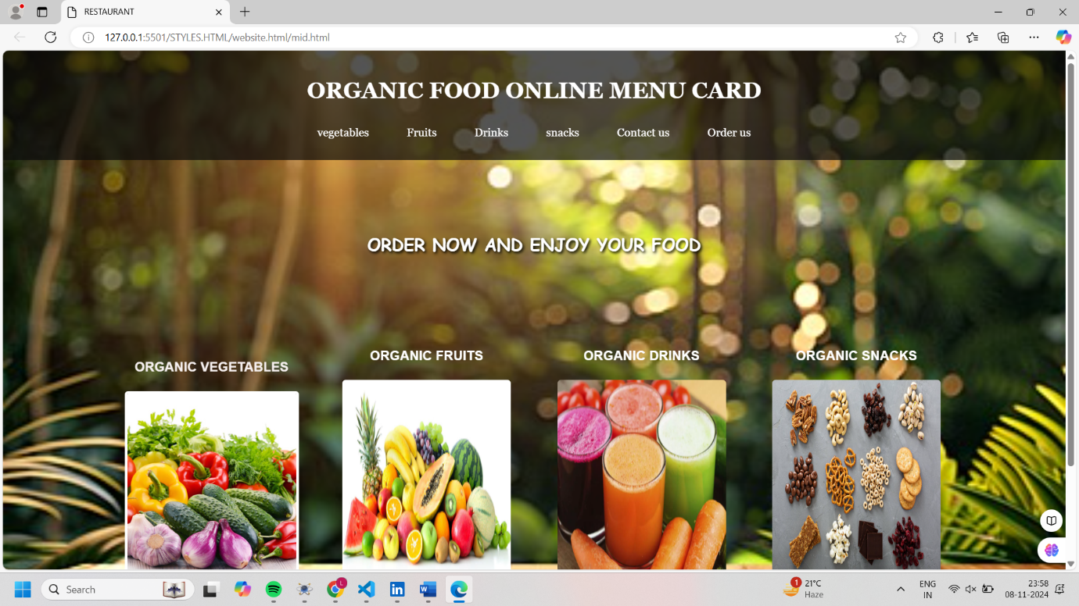

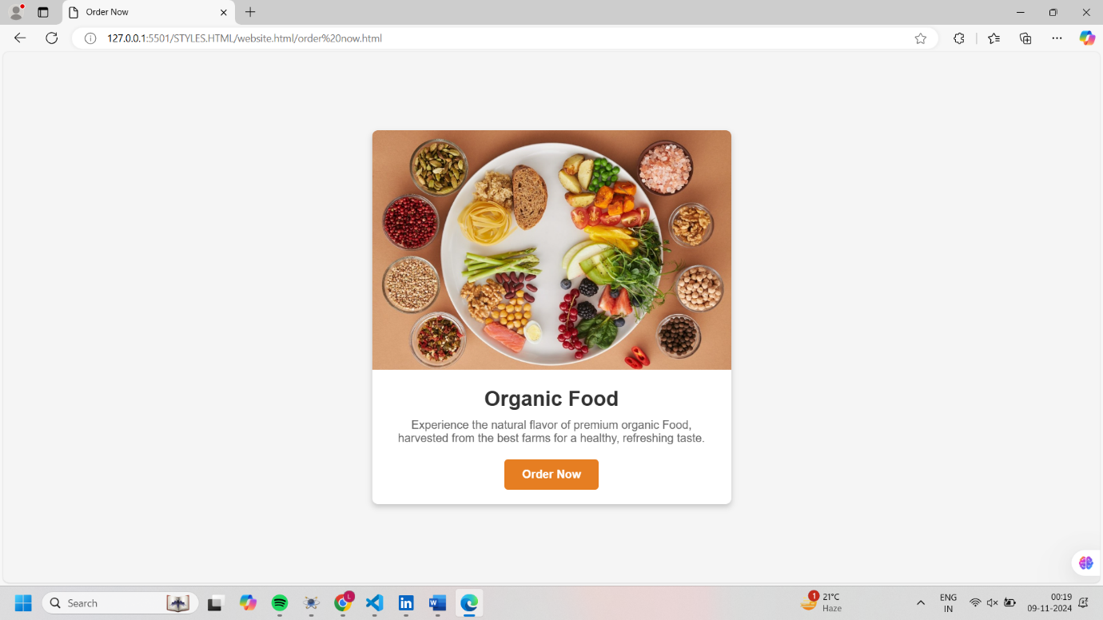

CONCLUSION:

An organic food website offering fresh vegetables, fruits, and homemade snacks can focus on the unique benefits of organic produce, emphasizing health, taste, and environmental advantages. Organic options are rich in nutrients, free from harmful pesticides, and contribute to sustainable farming that supports local communities. The website can feature guides on selecting seasonal fruits and vegetables, ensuring that customers receive the freshest and most flavorful produce. Homemade snacks provide a wholesome alternative to store-bought options, with no preservatives or additives, catering to those seeking convenient, nutritious choices. Additional content, such as easy recipes using organic ingredients and tips for reducing food waste, can help customers make the most of their organic purchases. With a focus on family-friendly options, like kid-friendly snacks, and informative sections on the health and environmental impact of organic farming, this website can inspire a transition toward an organic lifestyle while supporting local farmers and eco-friendly practices. Highlighting trends in organic snacks, such as energy bites and veggie chips, alongside popular smoothie recipes, offers customers a variety of ways to incorporate nutritious, chemical-free foods into their daily routines, fostering a healthier, more sustainable lifestyle.